**Power BI Assignment 3**

**1. List and explain different Power BI products.**

Ans: Power BI is a business analytics service provided by Microsoft that helps in visualizing your data and sharing insights. It converts data from different sources to build interactive[dashboards](https://www.simplilearn.com/tutorials/power-bi-tutorial/power-bi-dashboard) and Business Intelligence reports.

Different Power BI Products are explained inline:

Power BI Desktop: a Windows desktop application for data analysis and reports creation

Power BI Service: Online software as a Service, used to collaborate and distribute Power BI reports

Power BI Mobile: a native mobile app

Power BI Report Builder: a tool for creating paginated reports

Power BI Report Server: an on-premises report server (available through Power BI Premium licensing)

1. **What limitations of Excel, and Microsoft is solved by Power BI?**

Excel vs Power BI: Data Model

Microsoft Excel is mainly used for simple analysis tasks on historical data only while Power BI deals with the simplification of real-time data obtained from disparate sources, apart from complex analysis of historical data.

### Power BI vs Excel: Language Dependency

Microsoft Excel works with the MDX language for querying the underlying Data Model, while for Power BI, the DAX language is used

### Power BI vs Excel: Collaboration

Power BI lets you share your dashboards and reports with other employees in just a few clicks. This is available for people looking for On-Premise Solutions or In-Cloud Solutions catering to enterprises and small businesses alike.

Microsoft Excel, however, has limited scope for collaboration, integration, and a bunch of other functions and formats. Setting KPIs and organizing complex data structures is simpler in Microsoft Excel due to the presence of a rich set of mathematical formulas to help you along the way.

### Power BI vs Excel: Data Security

Microsoft Excel allows you to restrict access to a file, worksheet, or workbook. You can also lock the files to hide their visibility or give read-only access to prevent editing or modifications. This is all Microsoft Excel has to offer when it comes to Data Security. It does not have a robust, built-in security control, unlike Power BI. Power BI offers a rich assortment of measures to keep your customer data safe like:

* Row-Level Security Feature
* Role-Based Authentication
* Networking Security
* Risk Mitigation
* Session Monitoring
* Cloud-Based Security Provisions

### Power BI vs Excel: Data Visualizations

When it comes to data visualizations, Power BI trumps Microsoft Excel by its sheer ability to analyze a vast amount of data with great ease along with a wide range of charts like Tables, Area Charts, Doughnut Charts, Funnel Charts, etc.

### Power BI vs Excel: Reporting and Dashboarding

Microsoft Excel offers you a limited range of dashboards if you look at interactivity and the range of functions. It has a tabular data format that can help you visualize data with various chart formats. However, it is not an ideal tool for larger datasets. Power BI has a cohort of powerful features like easy formatting, natural language querying, resizing, editing, and filtering that make the reports easy to understand, and visually attractive, while helping you draw multi-faceted insights to guide the decision-making process. Power BI’s reports are highly dynamic and interactive.

1. **Explain Power Query?**

Power Query is a data transformation and data preparation engine. Power Query comes with a graphical interface for getting data from sources and a Power Query Editor for applying transformations. Because the engine is available in many products and services, the destination where the data will be stored depends on where Power Query was used. Using Power Query, you can perform the extract, transform, and load (ETL) processing of data

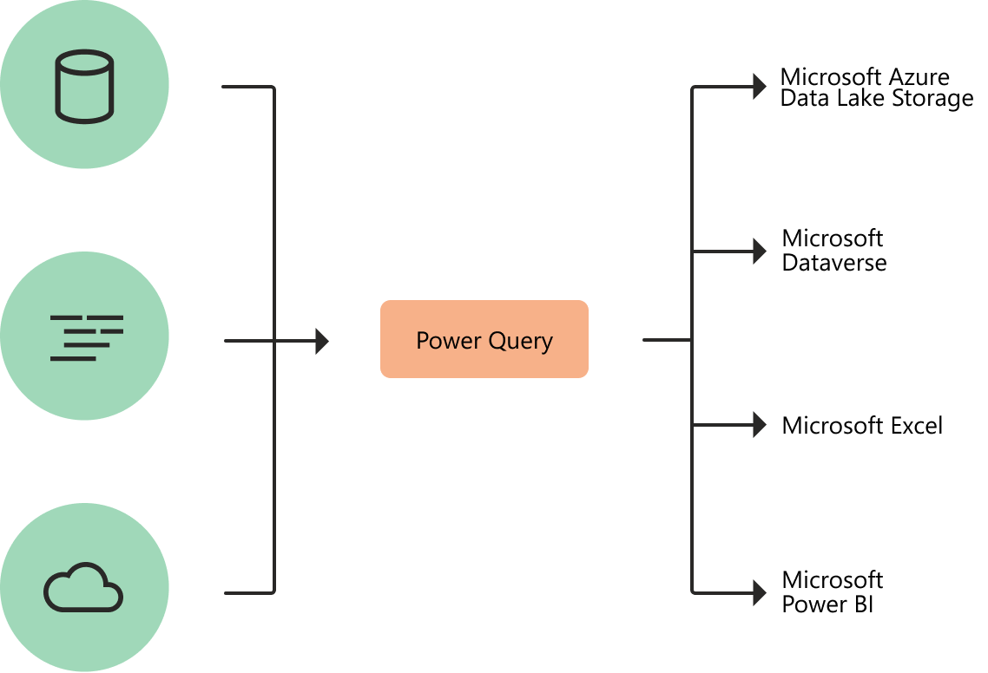

1. **Explain Power Map?**

Ans: Power Map is much more mature in 3D Geo-Spatial visualization, you can have different layers of visualization (such as column charts and heat maps, and region visualization). You can zoom into the map at a particular angle if you want to. You can have a play axis which is very important for storytelling.

1. **How has Power BI eliminated the need to host SharePoint Server on-premises?**

Ans: Power BI is a cloud technology for reporting however, it has also an on-premises solution for which we have Power BI Report Server.

Power BI Reporting server is an instance of reporting services. It’s a whole server hosting environment you set up on-premises and you can have Power BI reports in it. So basically it’s a centralized hosting environment that can have your interactive power bi reports which eliminate the need to host a SharePoint server on-premises.

1. **Explain the updates done in Power Bi Service(power BI 2.0) as compared to the older version?**

Ans: Here’s an overview of the changes:

**Browse changes** The left navigation links for **Recent**, **Favorites**, and **Shared with me** full-page lists are being combined in a new **Browse** tab. You can still search and filter these lists, and now can even filter by keyword.

**Left navigation changes** A major change coming to the left navigation pane is the tooltips. Before, to see what an icon represented in the left navigation pane, you had to expand the entire menu.

**Workspace flyout menu changes** The **My Workspace** link moves below the **Search** box in the workspace flyout menu.

**Get Data changes** The Get Data experience moves from the bottom of the left navigation pane to the **Create** tab.